LAB 2 - Hooking Up UI Components & Objective-C Objects

Objectives

- Link user interface (UI) components to code with the IBAction & IBOutlet keywords
- Understand how Objective-C implements objects’ instance variables

Tasks

Task 1 - Hook Me Up
The Interface Builder tool helps you design user interfaces. However, in most cases, unless you can control your UI elements from code, it is pretty useless. The IBOutlet and IBAction keywords tell Xcode that your code’s @property properties and public methods are “available” to Interface Builder, respectively.

Interestingly, both of these keywords are “precompiled” out of your code. They are not related at all to how your program executes in memory. They are merely signposts to communicate your design to the IDE (Interface Builder) and the compiler preprocessor.

- Create an application that allows a user to enter text & slider values for Red, Green, and Blue, and when “Update” is pressed, a large text label will update to the new text & color.

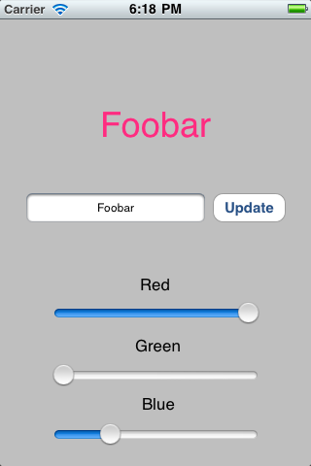
Hints:
- When creating the new project, use the View-based Application template (iPhone). This template creates a default UIWindow object and a default UIView (and view controller) for you to work with and place subviews (i.e. your sliders, buttons, text, widgets).
- Right-click a UI element in Interface Builder to bring up a context menu. Connect each element’s “referencing outlet” to the “File’s Owner”.

Task 2 - Synthesize This

Objective-C provides the @property and @synthesize keywords as “syntactic sugar” (shorthand) to quickly create instance variable getters/setters.
- Read Apple’s Declared Properties documentation: http://developer.apple.com/library/ios/#DOCUMENTATION/Cocoa/Conceptual/ObjectiveC/Chapters/ocProperties.html

- Write the getter/setter method implementations that are functionally equivalent to using @synthesize with the following @property declarations:

@property (nonatomic, retain) NSString *myText;
@property (nonatomic, copy) NSNumber *opacity;
@property (nonatomic, assign) id delegate;

The nonatomic keyword tells the compiler that you don’t need concurrent thread safety. For now it is safe to assume everything is nonatomic, and any property that is part of the UIKit framework (class name beings with UI) must be nonatomic. The default is atomic.

